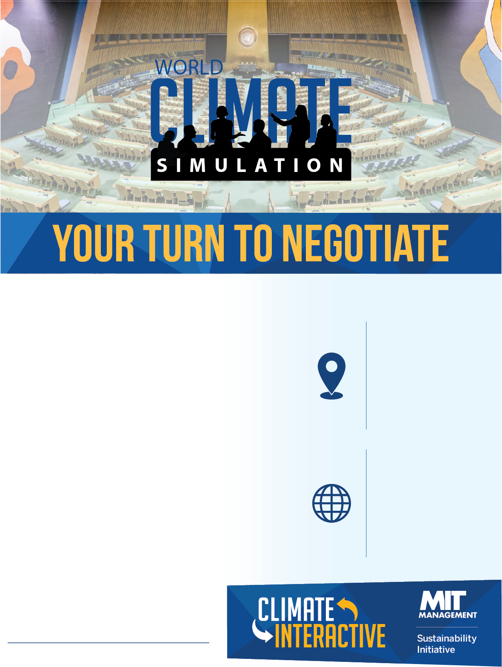

The **World Climate Simulation** is an interactive roleplaying exercise developed by Climate Interactive and MIT Sloan. This model-based game parallels the UN climate change negotiation process.

Participants will play world leaders who must produce a global agreement to reduce greenhouse gas emissions enough to limit global warming well below 2°C.

Join us to experience what it’s like to negotiate a climate deal and address one of the greatest human and environmental challenges of this century.

**To participate, please email:**

**Where**

Address

Time

Etc

**Connect**

@worldclimate

@climateinteract