C-ROADS Exercise:
Your Vision of International Climate Action Success

Imagine a time in the future when the people from three major regions of the world decide to address climate change. What do you think would be the best way to do it? What is your vision of international success on climate mitigation?

For this exercise, you’ll use the C-ROADS Climate Change Policy Simulator to test different climate mitigation scenarios. Your goal is to create a single scenario that limits warming to below 2°C by 2100. Consider economic impacts, international equity, viability, and other factors important to you as you choose your scenario.

Steps
- Access C-ROADS at https://www.climateinteractive.org/tools/c-roads/. You can choose to run the simulator online or download it as an offline application. If you are new to C-ROADS, review the ‘C-ROADS Overview’ video on the page.
- Use the 3 Region mode: In the menu bar, select Simulation 3 Region.
- After experimenting with various scenarios and exploring the different graph options to view the impacts of your scenarios, finalize your scenario and answer the following questions.

Questions
- What were your settings in the table below?
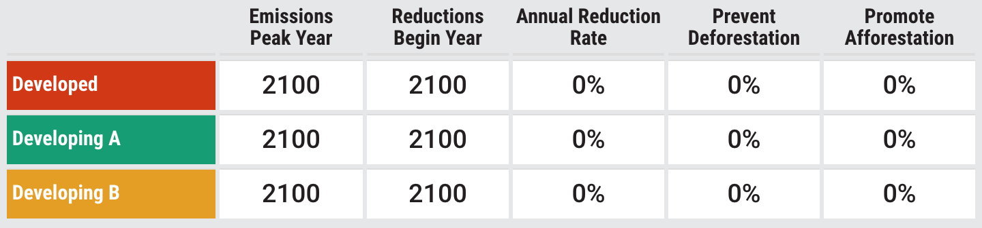

- What is the resulting “Temperature Increase by 2100”?

- Find a graph that illuminates a factor that you think is important in this scenario outside the default graphs. What is the variable and what does it show that is important or interesting?

- What about this scenario makes it the best way to address climate change?

- What would be the main arguments against your scenario from a head delegate from each of the three regions (Developed Nations, Developing A Nations, and Developing B Nations):

- What are two things that would need to happen in the world over the next ten years to make this scenario come true?

- How did it feel to create these scenarios?

