Assignment: Simulating Climate Futures in En-ROADS
In this assignment, you will work with the En-ROADS simulation model (developed by Climate Interactive and MIT Sloan Sustainability Initiative) to create a scenario that can mitigate global warming to the internationally agreed target of less than 2°C. In addition, you will consider the economic, political, and social issues relevant to successful implementation of your policies.

Your Steps
- Access En-ROADS at https://en-roads.climateinteractive.org/. Review these materials to help you understand how to use this model:
  - 20-minute introductory video to En-ROADS
[Link: https://youtu.be/7Muh-eoPd3g]
  - Quick Guide to the En-ROADS policy levers
[Link: https://www.climateinteractive.org/wp-content/uploads/2019/09/EnROADS-one-page-guide-to-control-panel-v9-new-layout.pdf]
- Develop a scenario to meet your goals. Use En-ROADS to develop your vision of how to successfully limit global warming to less than 2°C per the Paris Agreement. Ensure your scenario factors in the goals listed below.
- Submit a writeup expressing your vision. After developing your preferred scenario, write a thoughtful and concise response to the questions below. Develop your vision and approach on the issues. Instructions on how to format your writeup are at the end of this document.

Your Goals
Your mission is to recommend a set of global policies, investments, and actions that meet these five goals as much as possible:
- Limit global warming. Global warming above 2°C will cause dangerous and irreversible impacts that will harm our prosperity, security, health, and lives. Limiting warming to less than 2°C is not without challenges either (we are already seeing impacts today), however it is a benchmark by which scientists and world leaders believe we can lower the risks to a more manageable level.
- Preserve and create a healthy economy. Your policies should strive to lead a global energy transition that would preserve and create a healthy global economy. You must decide how to balance the short-term costs of climate actions with the long-term costs of damages from climate inaction. Note that financial costs are not explicitly predicted in the model as they are uncertain and controversial. You may offer your own hypotheses on the financial impacts of different decisions.
While assessing the economics, also consider the potential to offset short-term costs with additional co-benefits e.g., benefits to the economy, public health, national security and other areas which could provide benefits on top of the direct benefits of mitigating global warming.
- Promote equity and a just transition. Consider the impacts of your policies for both high-income and low-income nations, and between the rich and poor people within nations. Consider whether your policies will disproportionately harm certain groups and how to mitigate such harms (e.g., if you favor policies that would reduce or shut down fossil fuel use, how will your policies address the resulting unemployment of people employed by the fossil fuel industry?). Also consider how opportunities for the new green economy can be shared more equitably and not leave marginalized groups behind.
- Protect the environment. Many environmental challenges besides climate change threaten human welfare—e.g., water shortage, air and water pollution (smog, particulates), soil loss, plastic pollution, anoxic zones (dead zones) in rivers and oceans, extinction of species, etc. Your proposals should minimize other harmful effects on the environment.
- Be realistic but not cynical. Imagine a scenario of what could be possible if human civilization operates at its best.

Your Tool: En-ROADS
You will be testing your recommendations using the En-ROADS simulation model. En-ROADS is an interactive tool for simulating the long-term impacts of policy actions available to mitigate global warming e.g., policies affecting energy supply, energy efficiency, carbon emissions prices, land use, and other crucial factors that can mitigate greenhouse gas emissions. En-ROADS is grounded in the best available peer-reviewed science about climate impacts, solutions and the complex interactions of the climate, energy, land, population and economic systems.
Please note: En-ROADS is a global model, which means that the policy levers simulate if the action were applied to the whole world. En-ROADS does not attempt to address the complex nuances of how different countries and political groups might respond to each policy. En-ROADS is solely focused on the physical science of the feasibility and impacts of each solution.
More information on En-ROADS is available at: http://www.climateinteractive.org/simulations/en-roads

Your Write-up
Write a memo describing your proposals. Please respond to all the questions and organize your writeup into the following sections. There is no minimum or maximum length for your write-up. Create a compelling analysis with clear and focused writing.
Section 1: Plan
- Policies: Summarize your plan using the template provided at the end of this document. You may choose to share screenshots of specific graphs that caught your attention and are worth noting.
Section 2: Meeting the Goals
- Climate: How well do you think your proposal does in meeting the Paris climate goals? If it does not meet the goal, why is this acceptable to you?
- Economy: If the world followed your recommendations, how would the economy be different at different points in the future e.g., 2030, 2050 and 2100? In what ways would it be better? In what ways would it be worse?
- Equity: How can your proposal strive to increase equity across nations and different peoples?
- Environment: To what extent might your proposal mitigate other environmental challenges (e.g., biodiversity, pollution, water and air quality)? To what extent might your proposals cause or worsen other environmental problems?
- Realism without cynicism: What would it take for your proposal to be realized? What barriers might arise in the implementation of your proposals, and how might they be addressed? To get started, what actions and priorities are needed as soon as possible from businesses, civil society, governments, or the public?
Section 3: Reflections
- Winners/Losers: Who would be the biggest winners and losers globally in your proposed future? Create a table with two columns for winners and losers.
- Surprises from En-ROADS: What surprised you about the behavior of the energy and climate system as captured in the simulation? For example, what actions had a bigger or smaller effect than you thought? Did you discover why that might be?
- Feelings: How did your insights from the model and this assignment make you feel? (Feelings as in emotions, not thoughts.)
- Hope & Personal Action: What trends in the world give you hope that your proposals are possible? What can you personally do to help create the necessary changes?

Use this template to present your plan in section 1 of your write-up:
- Provide a short, memorable name for your plan
- Paste a screenshot of the main En-ROADS interface showing your results
- Present bullet points summarizing your most important policies and outcomes
- Paste the text from Actions & Outcomes to document all the assumptions and policy settings you choose in your scenario. Access the “Actions & Outcomes” feature from the “View” menu.
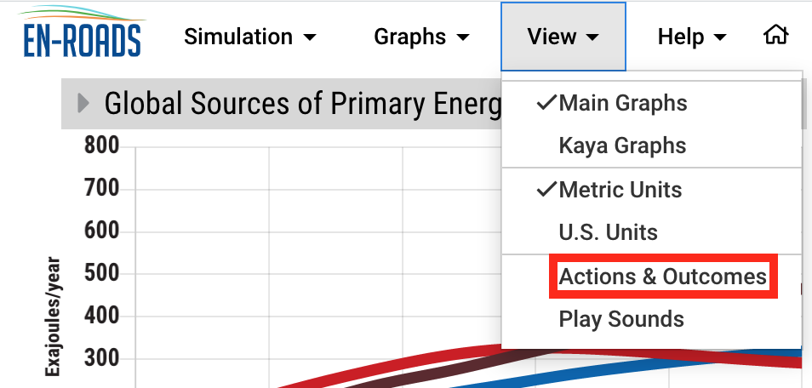
Figure 1: Actions & Outcomes

- Paste your URL from the “Copy scenario link” option in the Share Your Scenario feature on the top tool bar
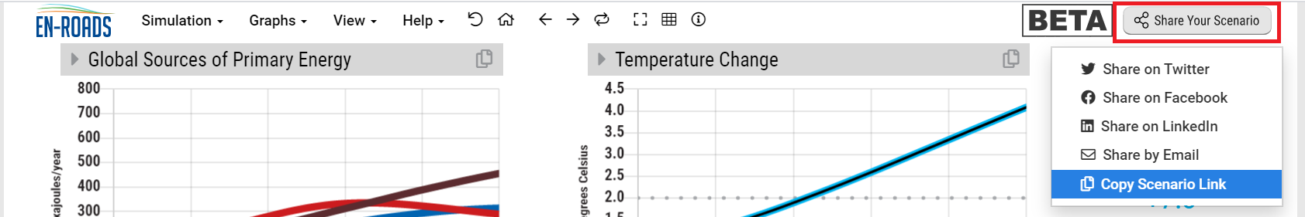
Figure 2: Copy scenario link

- Optional - You may choose to share screenshots of up to three specific graphs that caught your attention and are worth noting. For each graph you share, please add a brief note about why.
Illustrative Example
The example below is illustrative only. Note that the policies shown in the example do not reduce expected global warming to below 2 degrees C. Your preferred strategy should attempt to do so.
