Creating a Safer World: Achieving the Paris Agreement Target

You will have a chance to work with the En-ROADS simulation model (developed by Climate Interactive and MIT Sloan Sustainability Initiative) to create a set of policies that enacted together can mitigate global warming to the internationally agreed target of less than 2°C (3.6°F). We ask you to answer a few questions about the economic, political and social issues relevant to successful implementation of your policies.
Please ensure the name of the file you submit indicates the assignment number and your first initial and last name, for example, Assign1_ K_Kardashian.pdf.

Your Steps
- Access En-ROADS online at en-roads.org. Review these materials to help you understand how to use this model:
  - Quick Guide to En-ROADS control panel, graphs and policy levers [add link]
  - Watch this 20-minute introductory video to En-ROADS
- Develop a scenario to meet your goals. Use En-ROADS to develop your vision of success in limiting global warming to less than 2°C (3.6°F) as agreed in the Paris Accord and ensure your scenario factors in the additional goals listed below.
- Submit a writeup expressing your vision. After developing your preferred scenario, write a concise response to the questions below. There is more than one set of policies that will achieve the goals and many answers to the questions about potential barriers to implementation. We are interested in your approach and your views on the issues, and how you feel about the prospects for action and success in the real world. Detailed instructions on how to document and explain your preferred policies are appended to this document.

Your Goals
Your mission is to recommend a set of global policies, investments, and actions that meet these five goals as much as possible:
- Limit global warming. The 2015 Paris climate agreement, ratified by nearly all nations, called for “holding the increase in the global average temperature to well below 2 °C [3.6°F] above pre-industrial levels and pursuing efforts to limit the temperature increase to 1.5 °C [2.7°F]….”
- Preserve and create a healthy economy. Global warming above 2°C [3.6°F] will cause impacts that will harm our prosperity, security, health and lives. Limiting warming to less than 2°C [3.6°F] is not safe either, we are already seeing impacts today, but it is a benchmark by which scientists and world leaders believe we can lower the expected harms and risks of catastrophic damage to a manageable (albeit still challenging) level. Your policies should drive a global energy transition that would create and preserve a healthy global economy.
You must decide on the balance of the short-term costs of action to mitigate greenhouse gas emissions arising from your proposals and the long-term costs of the damage caused by climate change if we do not act. Financial costs are not explicitly predicted in the model as they are uncertain and controversial. While assessing this question, also consider the potential to offset short-term costs with additional co-benefits e.g., benefits to the economy, health, national security and others over and above the direct benefits of mitigating global warming.
- Promote equity and just transition. Consider the impacts of your policies for both developed and developing nations, and between the rich and poor within nations. Consider whether your policies will disproportionately harm certain groups and how to mitigate such harms (e.g., if you favor policies that would reduce coal use, how will your policies address the resulting unemployment of coal miners?).
- Protect the environment. Many environmental challenges besides climate change threaten human welfare—e.g., water shortage, air and water pollution (smog, particulates), soil loss, plastic pollution, anoxic zones (dead zones) in rivers and oceans, extinction of species, etc. Your proposals should minimize these harmful effects on the environment.
- Be realistic but not cynical. What would it take for your proposed policies to be implemented if human civilization operates at its best?

Your Tool: En-ROADS
You will be testing your recommendations using the En-ROADS simulation model. En-ROADS is an interactive tool for simulating the long-term impacts of policy actions available to mitigate global warming e.g., policies affecting energy production and use, energy efficiency, fuel mix, emissions prices, land use, and other crucial factors that can mitigate greenhouse gas emissions. En-ROADS is grounded in the best peer-reviewed science and evidence about climate impacts, solutions and the complex interactions of the climate, energy, land, population and economic nexus. This simulation model enables users such as yourself to access powerful analysis at your fingertips in order to explore policies and see results in real-time through the year 2100.
Please note: En-ROADS is a global model, which means that the policy levers simulate if the action were applied to the whole world. En-ROADS does not attempt to address the complex nuances of how different countries and political groups might respond to each policy. En-ROADS is solely focused on the technical feasibility and impacts of each solution as governed by the laws of natural science or what is physically possible.
More general information on the simulation is available here: http://www.climateinteractive.org/simulations/en-roads

Your Writeup
Write a brief memo describing your proposals. Please respond to all the questions and organize your writeup into the following four sections. There is no minimum or maximum length for your report. Longer is not necessarily better. Compelling analysis with clear, tight and focused writing will be rewarded.
Plan
- Policies. Summarize your proposals using the template provided at the end of this document. Your plan will summarize your approach and outcomes, and all the settings you chose in En-ROADS so that your results can be replicated. Optionally you may choose to share screenshots of specific graphs that caught your attention and are worth noting.
Meeting the Goals
- Climate. How well do you think your proposal does regarding meeting the Paris climate goals? If not well, why is this acceptable to you?
- Economy. If the world followed your recommendations, how would the economy be different in 2030? In what ways better? In what ways worse?
- Equity. To what extent does your proposal seem fair and equitable, across and within nations and different peoples?
- Environment. To what extent might your proposals address the climate problem and mitigate other environmental challenges? To what extent might your proposals cause or worsen other environmental problems?
- Realism without cynicism. What would it take for your proposal to be realized? What barriers might arise in the implementation of your proposals, and how might they be addressed?
Implications
- Winners/Losers. Who would be the biggest winners and losers globally in your proposed future?
- Role of business. What would be required of businesses around the world to help bring your proposal to fruition? Which industries would require the most significant transformation in thinking and leading?
- Getting started. To implement your proposals, what actions and priorities are needed over the next two years for businesses, civil society, government, and the public?
Reflections & Feedback
- Surprises. What surprised you about the behavior of the energy and climate system as captured in the simulation?
- Affect. How did the insights from the model and your assignment make you feel?
- Hope. How hopeful are you that society can address climate change? What needs to change for us to succeed? What can you personally do to help create those changes?
- Model flaws/areas for improvement: All models are approximations based on the best available data and science. Please note any bugs and behaviors you view as incorrect or implausible, and areas where you believe additional detail is necessary for realistic results. If you believe that you’ve discovered a bug in the model, attach three items: screenshot showing the problem, pasting the full set of policies which generated your problem using the “Scenario Listing” feature, and the scenario URL using the Copy Scenario Link button in the top tool bar. (see Figures 1 and 2 below)

Use this template to present your plan
- Provide a short, memorable name for your plan
- Paste a screenshot of the main En-ROADS screen showing your results
- Present bullet points summarizing your main policies and outcomes
- Paste the text from Actions & Outcomes to document all the assumptions and policy settings you choose in your scenario. Access the “Actions & Outcomes” feature from the “View” menu.
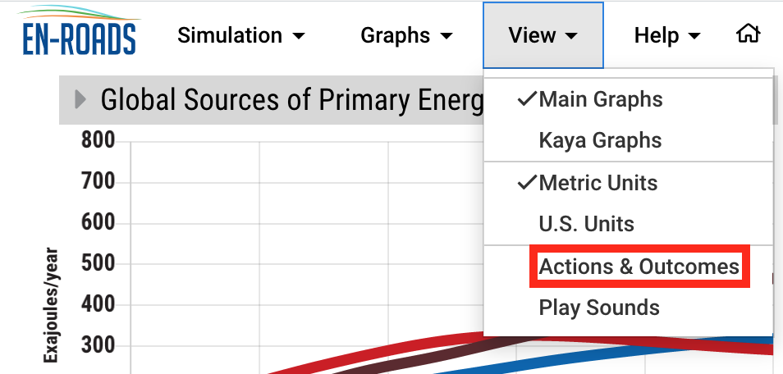
Figure 1: Actions & Outcomes

- Paste the URL from the “Copy scenario link” icon found on the main tool bar
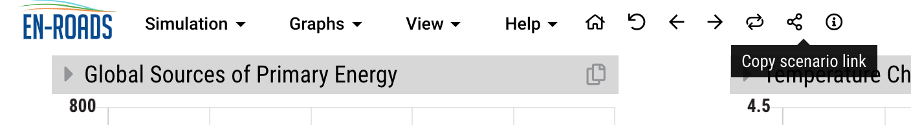
Figure 2: Copy scenario link

- Optional - You may choose to share screenshots of up to three specific graphs that caught your attention and are worth noting. For each graph you share, please add a brief note about why.

Illustrative Example
The example is illustrative only. Note that the policies shown in the example do not reduce expected global warming to the Paris Climate Accord. Your preferred strategy should attempt to do so.
