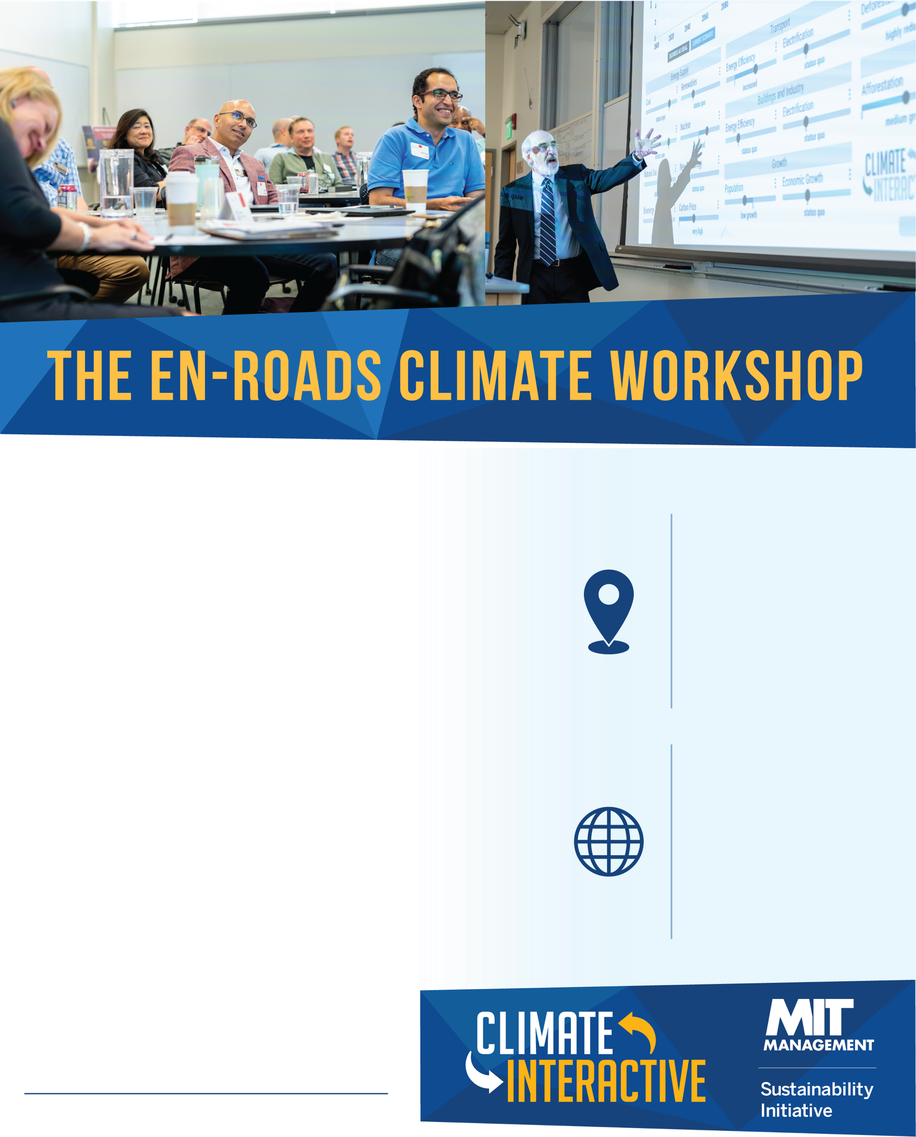­­­

The En-ROADS Climate Workshop helps build support for strategies to address climate change via interactive testing of the cutting-edge simulation model En-ROADS, created by Climate Interactive and MIT Sloan.   
  
In the workshop, participants propose climate solutions such as energy efficiency, carbon pricing, fossil fuel taxes, reducing deforestation, and carbon dioxide removal. The facilitator then tests these approaches using En-ROADS so that participants can see the impact on global temperature and other factors.

Join us to experience what it’s like to create your own climate future using grounded conversations; the resulting experience is hopeful, scientifically-grounded, action-oriented, and eye-opening.

**When & where:**

* *Address*
* *Date & time*
* *Other details to help participants find your event*

**Connect:**

@ClimateInteract

*climateinteractive.org*

*Host contact information*