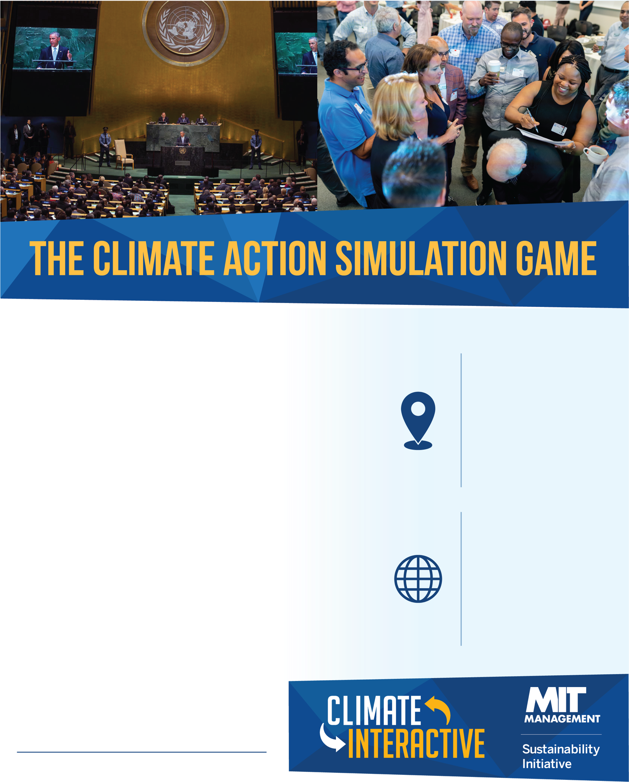­­­

**When & where:**

* *Address*
* *Date & time*
* *Other details to help participants find your event*

**Connect:**

@ClimateInteract

*climateinteractive.org*

The Climate Action Simulation is a highly interactive, role-playing game. It uses the En-ROADS simulation model to engage a wide range of participants in exploring key technology and policy solutions for addressing climate change.

The game is conducted as a simulated emergency summit organized by the United Nations that convenes global stakeholders to establish a concrete plan that limits warming to Paris Agreement goals.

Join us to experience what it’s like to negotiate a climate deal to address one of the greatest human and environmental challenges of this century.

*Host contact information*