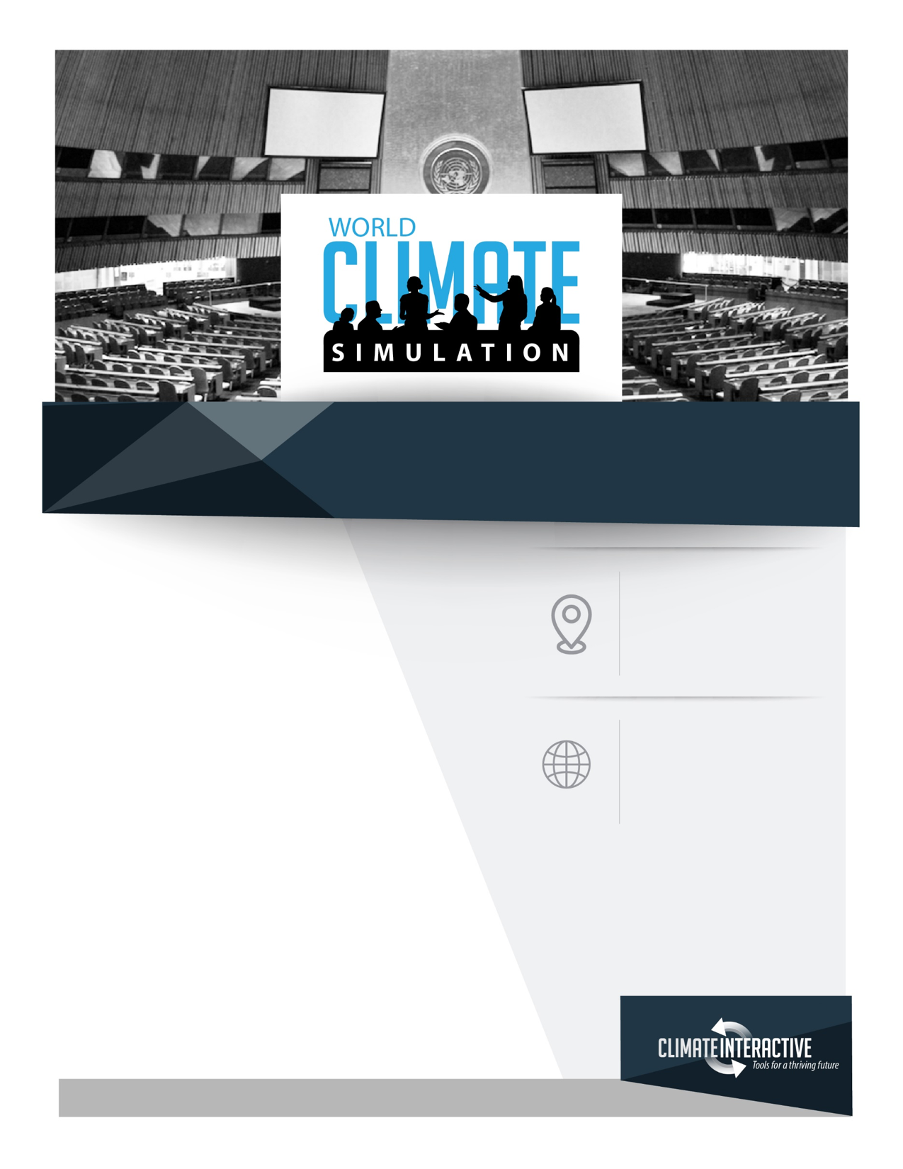

**Limit**

**climate change**

World Climate is an interactive

simulation of the international

climate negotiations. Developed

by Climate Interactive and MIT, this

model-based game parallels the

UN climate change negotiation process.

Participants, will play world leaders

who must produce a global agreement

to reduce CO2 emissions enough to limit

global warming well below 2°C.

Join us to experience what it’s like to

negotiate a climate deal and address one

of the greatest human and environmental challenges.

of this century.

To participate, please **RSVP**: ________________________

**Where**

**Address**

**Time**

**Etc**

**Connect**

**@worldclimate**

**@climateinteract**

Your Turn to Negotiate