WORLD ENERGY ANSWER SHEET

NAMES:_______________________________________________________________
Introduction
You are gathered here today as leaders of the key sectors that influence the energy system and the greenhouse gas emissions that threaten our climate. In December, 2015, 190 countries reiterated a goal of limiting global warming to below 2 ˚C and asserted the desire to stay within 1.5 ˚C. You represent the sectors that have the power to meet this objective.

At the same time, the commitments put forth by these nations failed to deliver the deep cuts in emissions needed to meet this goal. The UN therefore has brought together multinational corporations, government ministers with shared expertise, and leaders of citizens groups and NGOs to reach across political boundaries and work within their spheres of action and influence.

Your role is to demonstrate to government leaders and heads of state that there is a feasible, actionable path to stay below 2 ˚C of warming and to give those leaders a roadmap for achieving it. Time is short. You are charged with providing world leaders with a plan they can support. Given that political will in their home countries for climate action is mixed, your plan should be compelling and give government leaders what they need to advocate for action without losing their political standing.

You have the capacity to take substantive measures to move nations towards a low-carbon world. You have been brought here today to work both within and across your sectors and to negotiate the best possible outcome. You are well aware of what is at stake. We are beyond a time of half-measures and incremental change. The best available science shows that greenhouse gases emitted by human activity have already increased global temperature by 0.8 degrees Celsius and the risks of further climate change to our economy and to human welfare are serious.

Avoiding the worst impacts is possible. You must balance the need for action with the realities of your own and your stakeholders’ needs. Good luck.

REFERENCES
World Energy: Climate and Energy Policy Negotiation Game
https://www.climateinteractive.org/programs/world-energy/

Worksheet developed by Krista C. James, University of Wisconsin-Stout, for use with the World Energy Simulation.

World Energy Simulation
Our group is representing:
Energy Supply Land & Agriculture  Energy Efficiency Population &  Consumption | Carbon Pricing  Climate Activists

- Introduce yourselves.

- Read over your group’s briefing materials and formulate your negotiating strategy
  - What are your vital interests?

  - What is politically feasible for your sector?

  - What do you need from the other sectors?

  - What can you offer them?

- Secretary General calls the Conference of the Parties to order and addresses the Delegates. Goals:
  - Achieve commitments to stabilize emissions by 2100 at a level that limits global warming to no more than 2ºC above preindustrial levels.
  - Agree on a deal to distribute revenue from Carbon price (if any).

- Talk to the other teams and negotiate for the best possible outcome for your group. Be sure to play your role fully to the best of your understanding.

- Rejoin your group members and complete the proposal form for your group (copies from your instructor).

- Two-minute plenary presentation by representative of each delegation describing their emissions proposal, their fund commitment and why. Instructor will help summarize the data on the whiteboard.

- When the data from all the proposals is entered into the En-Roads model, what do you predict the temperature outcome will be by 2100 (see graph below)?
Circle one of the following: A B C D E F G

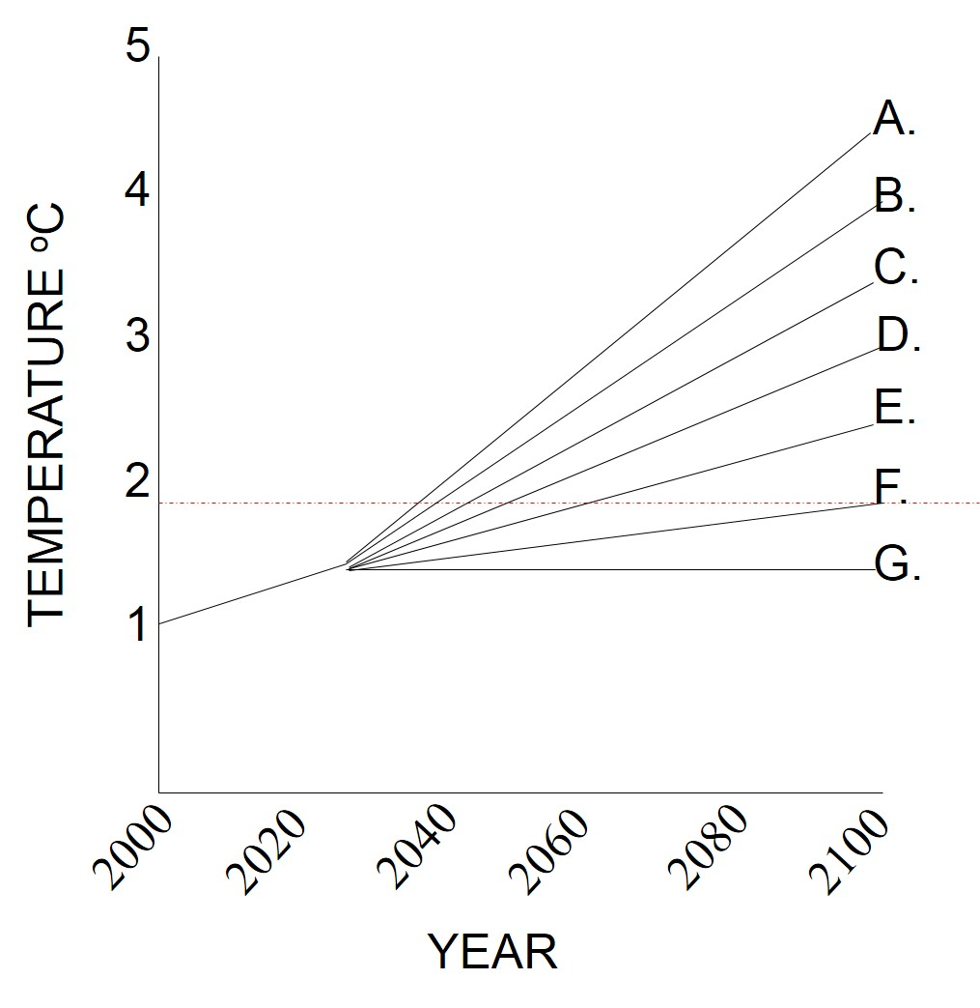

- EN-ROADS Model Round 1 Results
  - Did your actions solve the whole problem? Explain.

  - Did your actions help? Explain

  - Practice using the En-ROADS model before Round 2 Negotiations. What did you learn about what needs to be done to reduce greenhouse gas levels by 2100 at a level that limits global warming to no more than 2°C above preindustrial levels?

- Round 2 Negotiations: Now that you see that significant reductions in emissions are needed, each team will dispatch negotiators to work out a deal with other teams.

- Rejoin your group members and complete the proposal form for your group (copies from your instructor).

- Two-minute plenary presentation by representative of each delegation describing their emissions proposal, their fund commitment and why.

- EN-ROADS Model Round 2. To what extent did your proposals taken together produce the result you expected, or hoped for? Why or why not?

- Debrief
  - What impact do you envision the result you achieved (in either round) will have on climate stability, on the earth’s livability? On the interests you were representing in the exercise?

  - To what extent is the result you achieved (in either round) feasible? From an economic standpoint? A political standpoint? A social or cultural standpoint?

  - What do you see as the different benefits and values expressed in the varying approaches to the distribution of revenue from carbon pricing?

  - What are some positive actions individual citizens like you can undertake? Who else would you need to involve to achieve a more favorable outcome?

